**VETRI IT SYSTEMS PRIVATE LIMITED**

**PROJECT REPORT**

**PROJECT TITLE: ADVENTURAGE WEBSITE**

**1. Project Overview**

**Project Name:** Adventurage Website  
**Project Assigned Date:** 30-06-2025  
**Planned Completion Date:** 05-07-2025  
**Delivery Date:** 04-07-2025

**2. Project Team**

* **Project Manager:** Alagu Mari
* **Designer:** Malathy
* **Developer(s):** Nivashini D
* **Testing Team:** Yogavarshini

**3. Technology Stack**

* **Frontend Technologies:** HTML, CSS,Bootstrap,Javascript
* **Backend Technologies:** -
* **Database:** -
* **Infrastructure:** Nginx, Gunicorn, VPS Hosting

**4. Project Scope**

To develop a comprehensive, responsive, and user-friendly website for an adventureage travel agency that enables users to browse, and book travel packages. The platform will offer full-service support, including **accommodation**, **guides**, **food**, and optional activities.

**Key Objectives:**

* Filters: Destination, Difficuly level and Various other activities
* It is easy to find the packages the customers need.
* List of available guides with expertise, language, experience
* Support mobile and desktop responsiveness for seamless user experience.

**5. Project Modules**

* Home Page / Tour Page
* Tour PackagePage
  + Europe
  + Asia
  + Africa
  + North America
  + South America
  + Oceania
* Destination Page
  + Destination 1
  + Destination 2
  + Destination3
* Login Page
* Booking Page
* Payments Page
* Card Details page
* Order Received Page
* Contact Us Page
* Terms & Conditions Page
* Our Story Page
* Our Impact Page
* Meet the team Page
* Privacy Policy Page

**6. Project Code**

**Frontend Code (HTML Example):**

<div class="m-4">

        <!--Introduction-->

        <div class="introflex">

            <h1>Your Next Adventure Awaits!</h1>

            <div>

                <p>

                    Discover breathtaking locations, distinct experiences, and memorable travels with Adventurage.

                </p>

                <a href="" class="buttonbg">Dicover More

                    <img src="images/discover icon.png">

                </a>

            </div>

        </div>

        <!--Header image-->

        <!--To display only in small screen-->

        <img class="img-fluid smallscreenimg" src ="images/header image.png">

        <div class="headerview">

            <div class="headerdetails">

                <div>

                    <img src="images/location icon.png" alt="location"> Location

                    <h6>Gulmarg Valley, Kashmir</h6>

                </div>

                <div>

                    <img src="images/check in icon.png" alt="checkin"> Check-In

                    <h6>27, June 2025</h6>

                </div>

                <div>

                    <img src="images/check out icon.png" alt="checkout"> Check-Out

                    <h6>30,June 2025</h6>

                </div>

                <div>

                    <img src="images/people icon.png" alt="people">

                    People

                    <h6>2 Adults, 2 Children</h6>

                </div>

                <div>

                    <div class="buttonbg"><img src="images/search icon.png"> </div>

                </div>

            </div>

        </div>

        <!--Tabbed interface-->

        <div >

            <div class="tabs">

            <a class="tab-button" data-tab="tab1">Destination</a>

            <a class="tab-button" data-tab="tab2">Activities</a>

            <a class="tab-button" data-tab="tab3">Collection</a>

            </div>

            <div class="tab-content">

                <div id="tab1" class="content active">

                    <div class="destinationgrid">

                            <div class="destination-items"> <a href="europe.html">

                                <img src="images/europe home.png">

                                <div class="white-bg-button destination-button1">Europe</div>   </a>

                            </div>

                            <div class="destination-items"> <a href="asia.html">

                                <img src="images/asia home.png">

                                <div class="white-bg-button destination-button2">Asia</div>   </a>

                            </div>

                            <div class="destination-items">  <a href="africa.html">

                                <img src="images/africa home.png">

                                <div class="white-bg-button destination-button3">Africa</div>   </a>

                            </div>

                            <div class="destination-items">  <a href="southamerica.html">

                                <img src="images/south america home.png">

                                <div class="white-bg-button destination-button4">South America</div>    </a>

                            </div>

                            <div class="destination-items"> <a href="northamerica.html">

                                <img src="images/north america home.png">

                                <div class="white-bg-button destination-button5">North America</div>    </a>

                            </div>

                            <div  class="destination-items"> <a href="oceania.html">

                                <img src="images/oceania home.png">

                                <div class="white-bg-button destination-button6">Oceania</div>   </a>

                            </div>

                        </a>

                    </div>

                </div>

                <div id="tab2" class="content">

                    <div class="destinationgrid">

                            <div class="destination-items"> <a href="">

                                <img src="images/Activity1.png">

                                <div class="white-bg-button activity-button1">Hiking</div>   </a>

                            </div>

                            <div class="destination-items"> <a href="">

                                <img src="images/Activity2.png">

                                <div class="white-bg-button activity-button2">Cycling</div>   </a>

                            </div>

                            <div class="destination-items">  <a href="">

                                <img src="images/Activity3.png">

                                <div class="white-bg-button activity-button3">Rafting</div>   </a>

                            </div>

                            <div class="destination-items">  <a href="">

                                <img src="images/Activity4.png">

                                <div class="white-bg-button activity-button4">Snorkeling</div>    </a>

                            </div>

                            <div class="destination-items"> <a href="">

                                <img src="images/Activity5.png">

                                <div class="white-bg-button activity-button5">Wild Swimming</div>    </a>

                            </div>

                            <div  class="destination-items"> <a href="">

                                <img src="images/Activity6.png">

                                <div class="white-bg-button activity-button6">Northern Lights</div>   </a>

                            </div>

                        </a>

                    </div>

                </div>

                <div id="tab3" class="content">

                    <div class="destinationgrid">

                            <div class="destination-items"> <a href="">

                                <img src="images/Collection1.png"  class="img-fluid">

                                <div class="white-bg-button collection-button1">New Adventure</div>   </a>

                            </div>

                            <div class="destination-items"> <a href="">

                                <img src="images/Collection2.png"  class="img-fluid">

                                <div class="white-bg-button collection-button2">Winter Sun</div>   </a>

                            </div>

                            <div class="destination-items">  <a href="">

                                <img src="images/Collection3.png"  class="img-fluid">

                                <div class="white-bg-button collection-button3">Desert & Dunes</div>   </a>

                            </div>

                            <div class="destination-items">  <a href="">

                                <img src="images/Collection4.png"  class="img-fluid">

                                <div class="white-bg-button collection-button4">Foodie Adventure</div>    </a>

                            </div>

                            <div class="destination-items"> <a href="">

                                <img src="images/Collection5.png"  class="img-fluid">

                                <div class="white-bg-button collection-button5">Jungle Adventure</div>    </a>

                            </div>

                            <div  class="destination-items"> <a href="">

                                <img src="images/Collection6.png"  class="img-fluid">

                                <div class="white-bg-button collection-button6">Islands Adventure</div>   </a>

                            </div>

                        </a>

                    </div>

                </div>

            </div>

        </div>

**CSS Code:**

 * {

    margin: 0;

    padding: 0;

    box-sizing: border-box;

    font-family: 'DM SANS', sans-serif;

}

.logotext{

    font-family: 'Dokdo', cursive;

    font-size: 2rem;

    }

.header_bar{

    background-color: #16404D;

    text-align: center;

    color: white;

    padding: 0.5rem;

    margin-bottom: 1rem;

}

a {

    text-decoration: none;

    color: black;

}

.trips{

    text-decoration: underline;

    color: white;

}

.navbar-background{

    background-color: #c8efff;

    width: fit-content;

    border-radius: 1rem;

    font-size: 1.5rem;

}

.navactive{

    text-decoration: underline;

    text-underline-offset: 6px;

    font-family: 'Dokdo', cursive;

}

.login{

    background-color:#c8efff;

    border-radius: 1rem;

    padding:1rem;

    height:fit-content;

}

.textspacing{

    margin-right: 7rem;

}

.textspacing1{

    margin-right: 6rem;

}

.backgroundcolor{

    background-color: #c8efff;

    width: fit-content;

    border-radius: 10px;

}

.underline{

    width: 15rem;

}

.inputwidth{

    width: 15rem;

}

.introflex{

    margin:2rem;

    display: flex;

    justify-content: space-between;

    align-items: center;

    gap: 10em;

}

@media (max-width: 768px) {

.introflex{

     gap: 1rem;

      flex-wrap: wrap;

}

}

.introflex h1{

    font-size: 4rem;

}

.introflex p{

    font-size: 1.5rem;

}

.buttonbg{

    background-color: #16404D;

    color: white;

    padding: 1rem;

    border-radius: 1rem;

    display: flex;

    gap: 1rem;

    width: fit-content;

}

.headerview{

    background-image: url(../images/header\ image.png);

    background-repeat: no-repeat;

    background-size:auto;

    position: relative;

    height: 70vh;

    margin:3rem;

}

@media (max-width: 768px) {

.headerview{

    height: fit-content;

    background-image: none;

}

}

.headerdetails{

    position: absolute;

    left:10rem;

    top: 23rem;

    background-color:#c8efff;

    display: flex;

    justify-content: center;

    align-items: center;

    gap:5rem;

    padding: 1rem;

    border-radius: 2rem;

}

@media (min-width: 769px) and (max-width:1024px) {

     .headerdetails{

        flex-wrap: wrap;

        left:2rem;

        top: 23rem;

        gap:1rem;

        margin:1rem;

     }

}

@media (max-width: 768px) {

    .headerdetails{

    position: static;

    flex-direction: column;

    padding: 0.5rem;

    gap:1rem;

}

}

.smallscreenimg{

    display: none;

}

@media (max-width: 768px) {

.smallscreenimg{

    display: block;

}

}

.tabs {

    display: flex;

    margin-bottom: 10px;

    justify-content: flex-start;

    flex-wrap: wrap;

}

.tab-button {

    padding: 10px 20px;

    margin-right: 5px;

    cursor: pointer;

    transition: background-color 0.3s;

}

.tab-button.active {

    color: #16404D;

    border-bottom: 2px solid black;

    text-decoration: none;

}

.tab-content .content {

    display: none;

}

.tab-content .content.active {

    display: block;

}

.destinationgrid{

    display: grid;

    grid-template-columns: repeat(6,1fr);

    max-width: 100%;

    justify-items: center;

    align-items: center;

}

@media (min-width: 769px) and (max-width:1024px) {

    .destinationgrid{

    grid-template-columns: repeat(3,1fr);

    margin:2rem;

}

}

@media (max-width: 768px) {

    .destinationgrid{

    grid-template-columns: 1fr;

     margin:2rem;

}

}

@media (max-width: 768px) {

.fujiimg{

    width:100%;

}}

.destination-items{

    position: relative;

    width:fit-content;

    margin:0.1rem;

}

**7. Output & Screenshots(Add your website screenshots here)**

* **Homepage :**

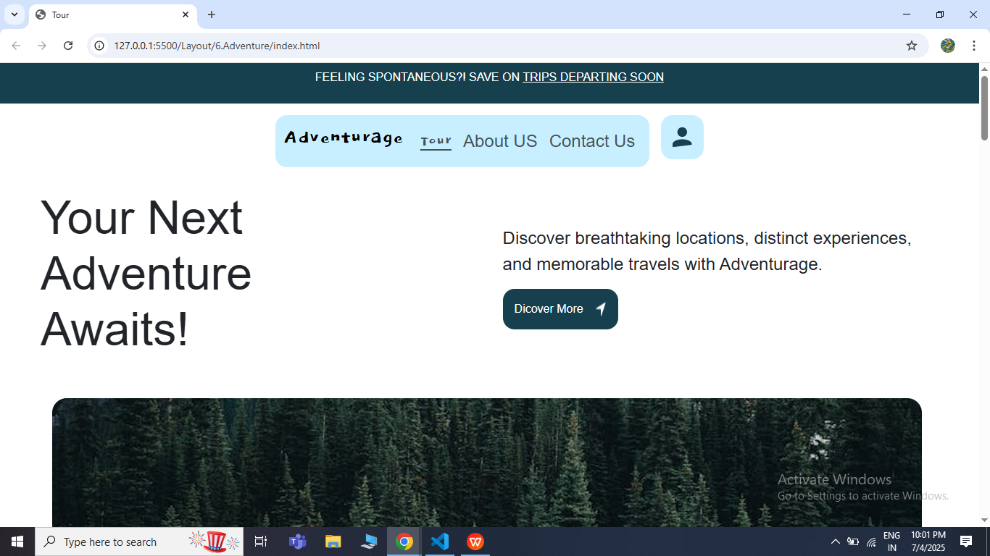

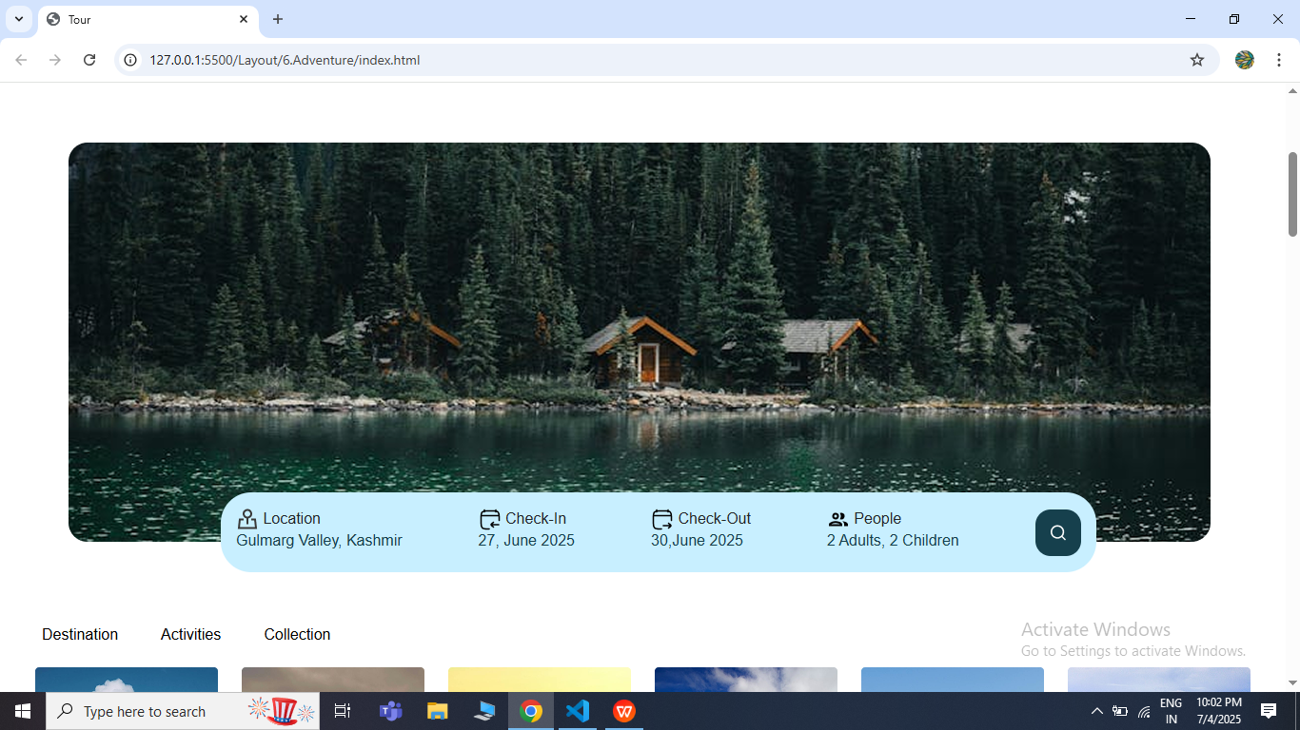

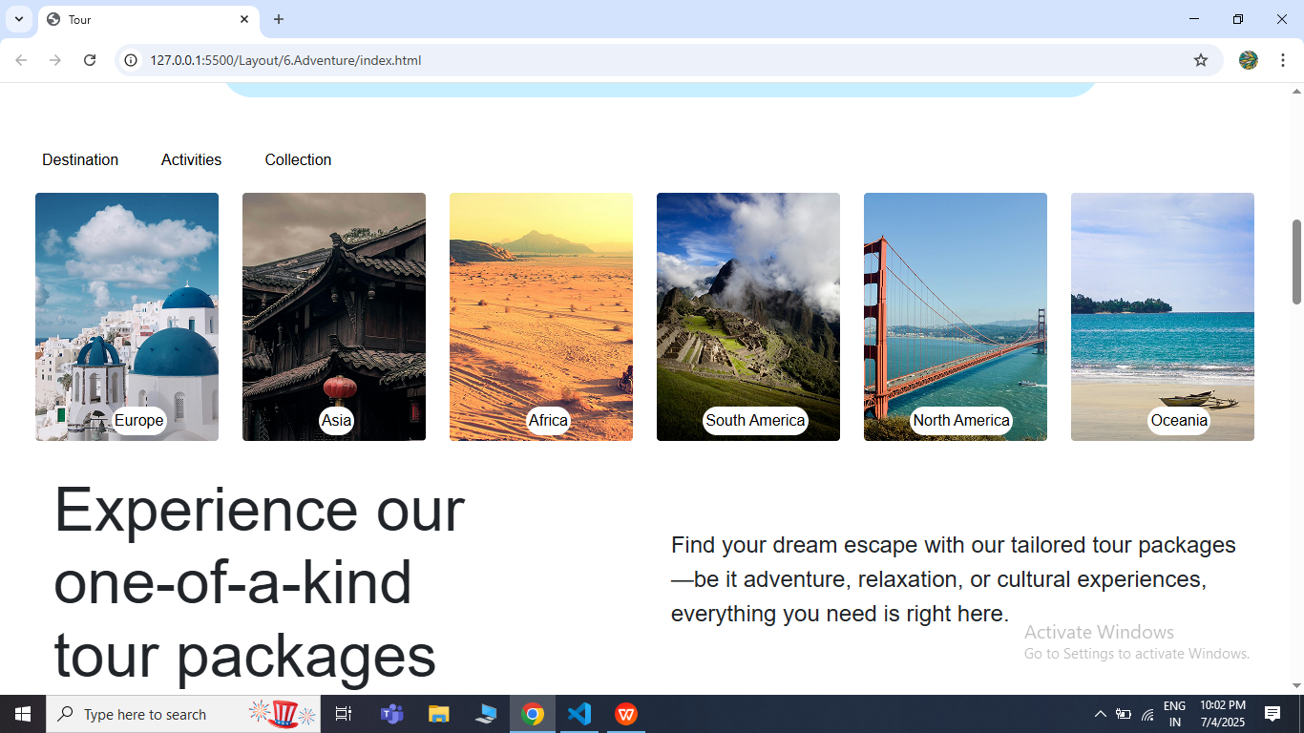

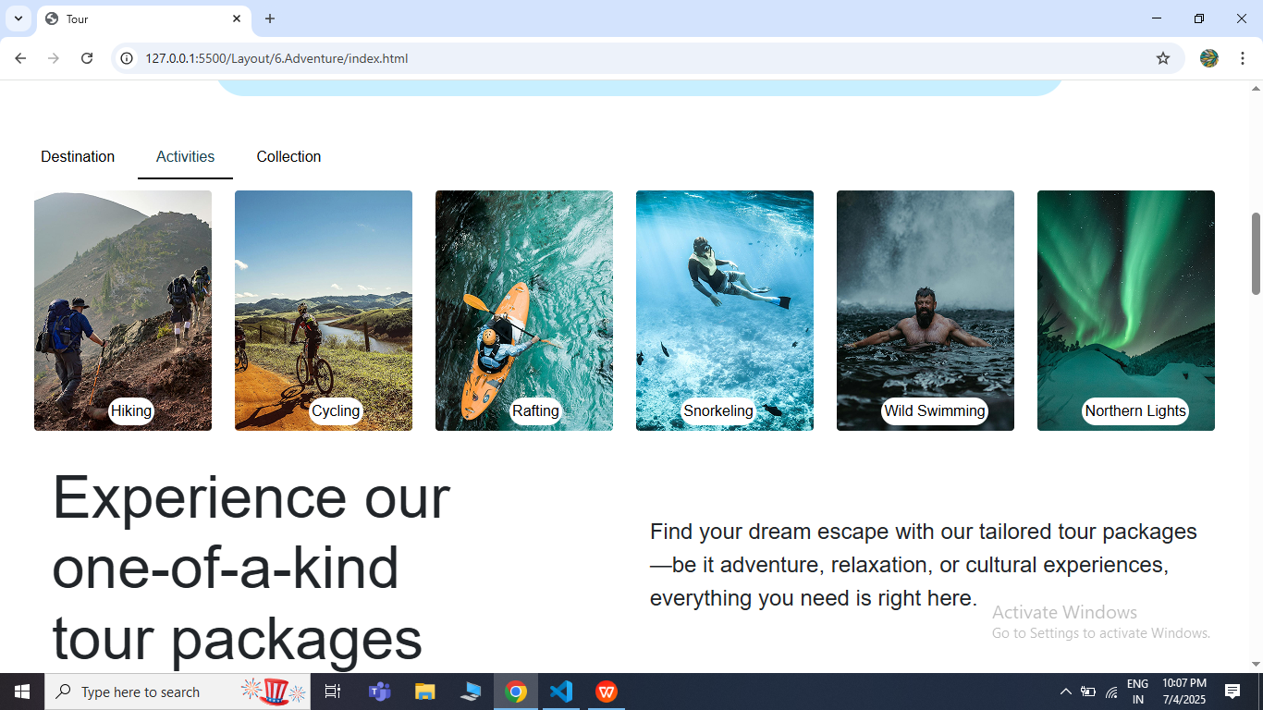

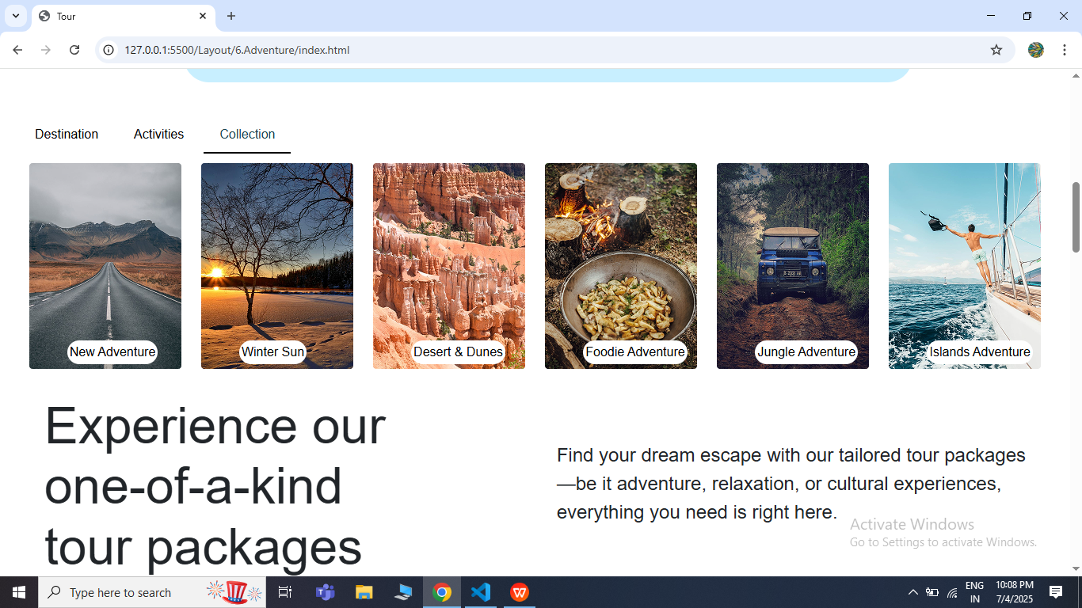

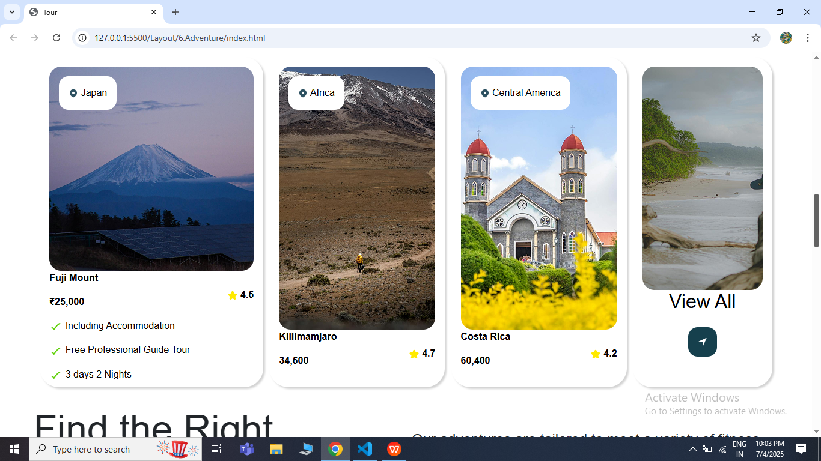

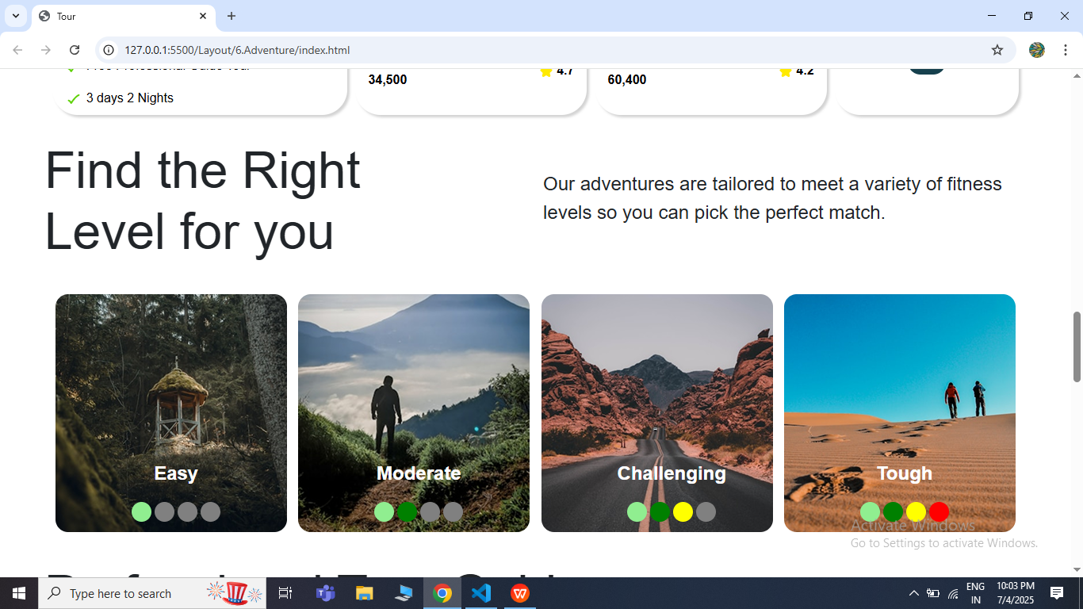

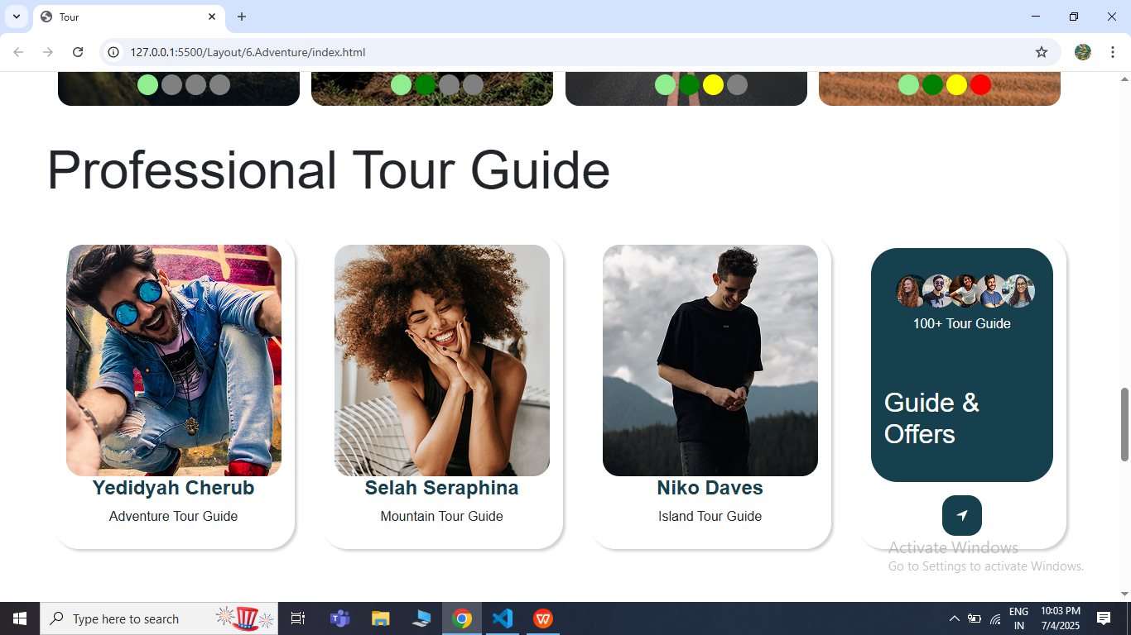

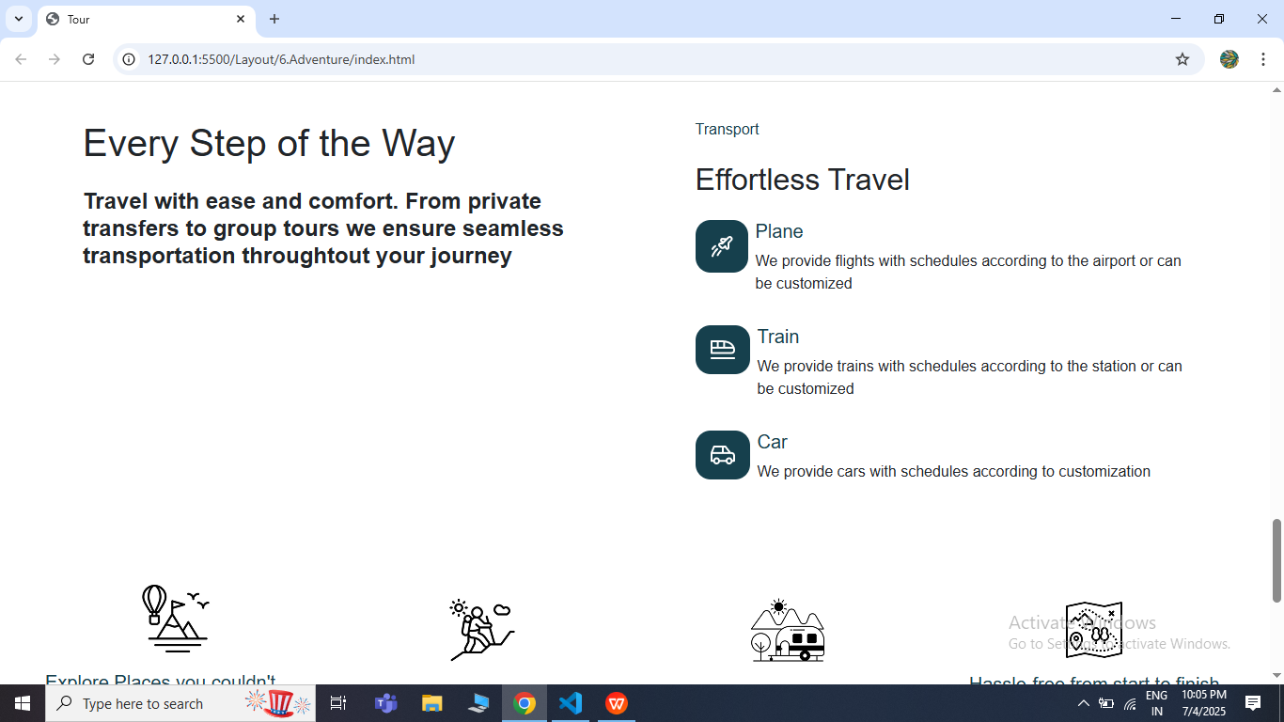

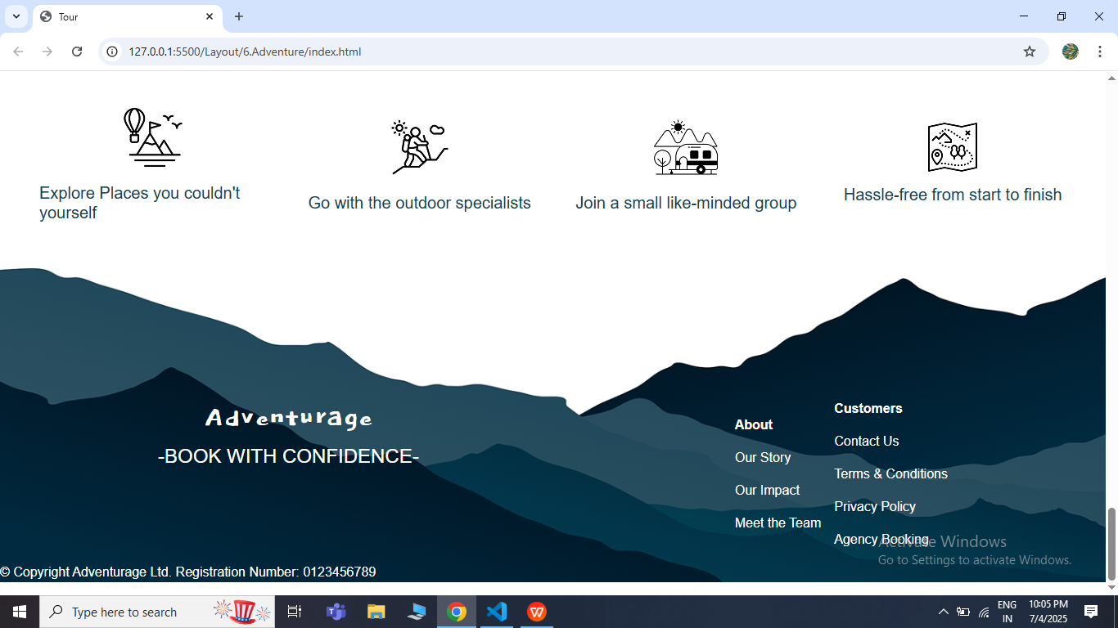

* **About Us:**

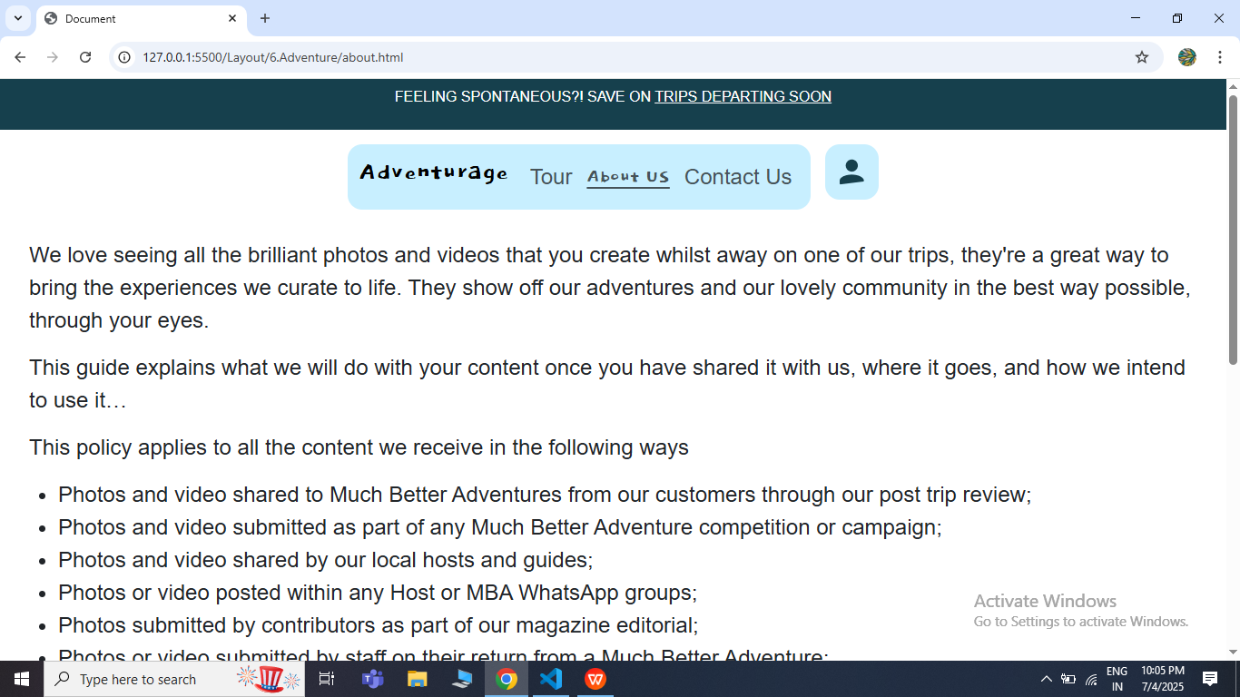

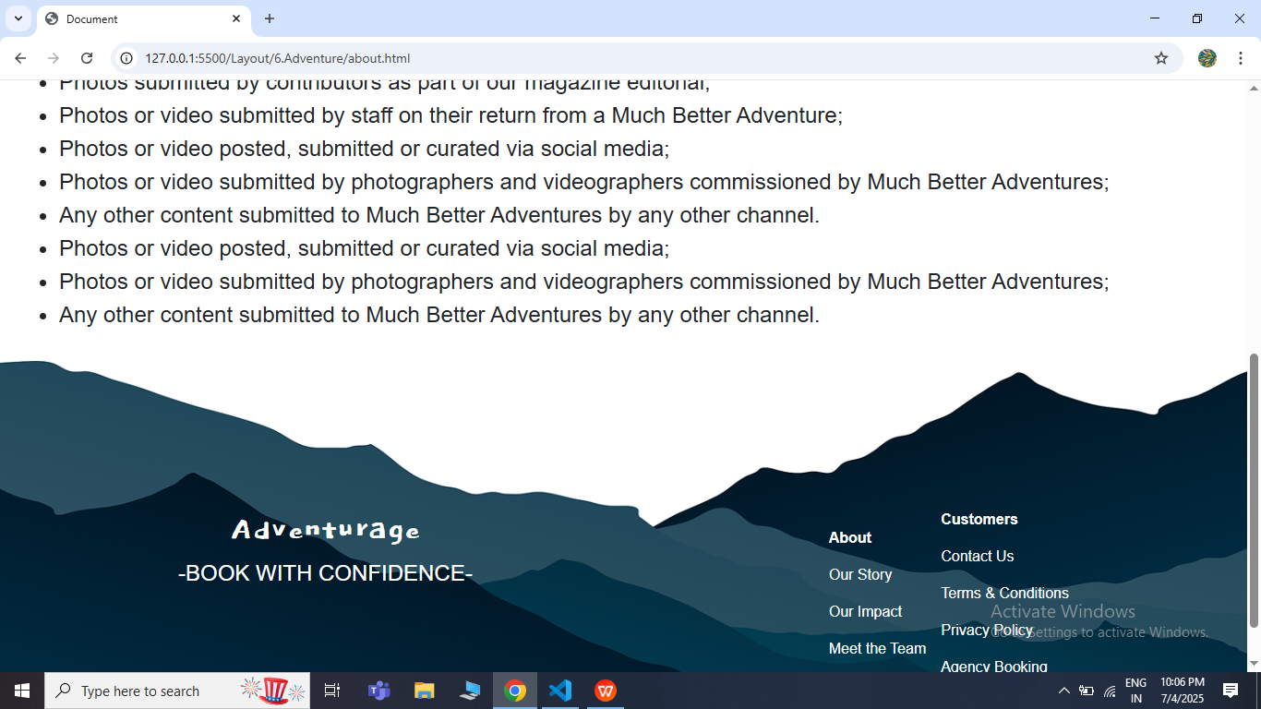

* **Contact Us Page:**

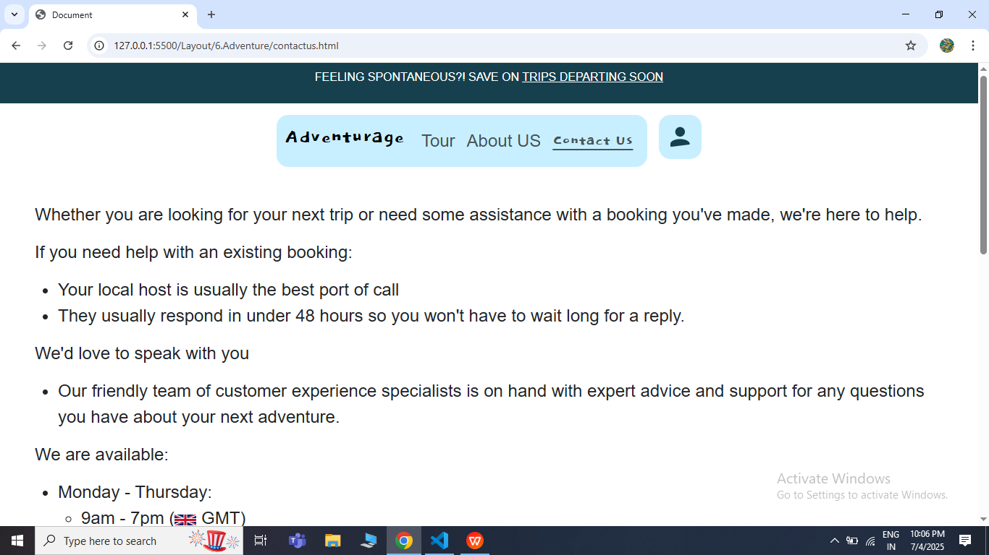

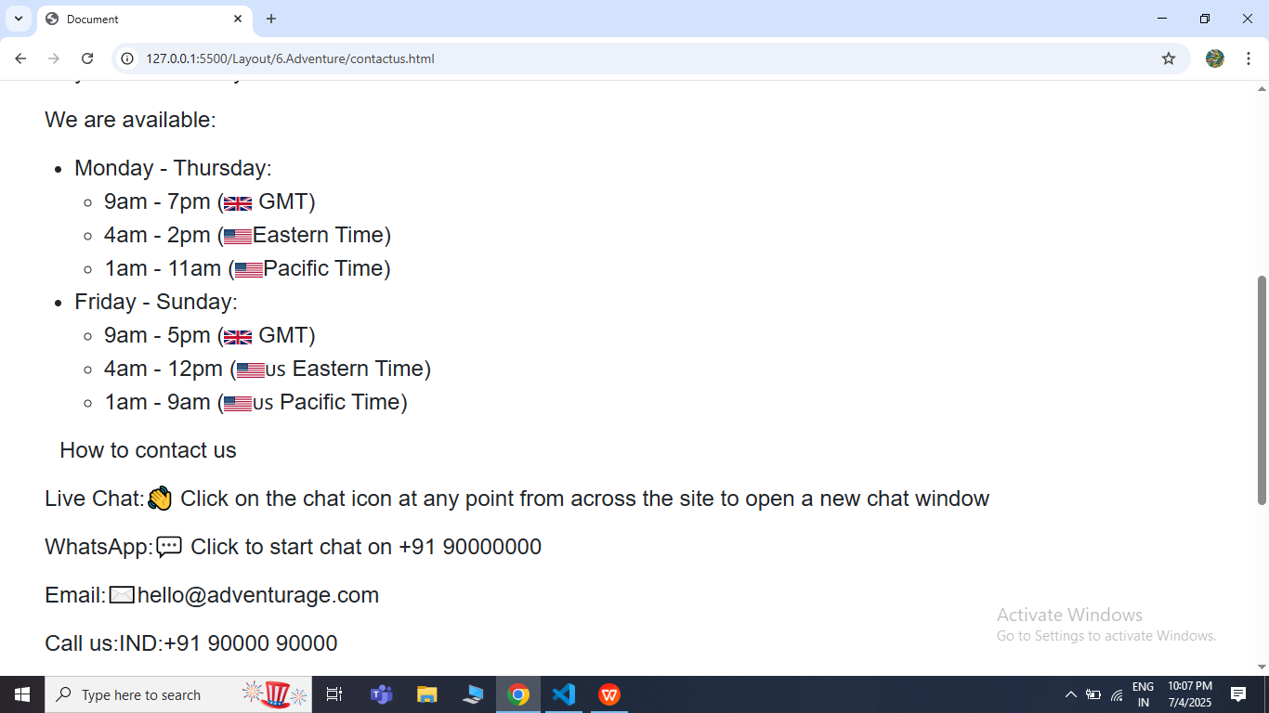

* **Tour Package Page**

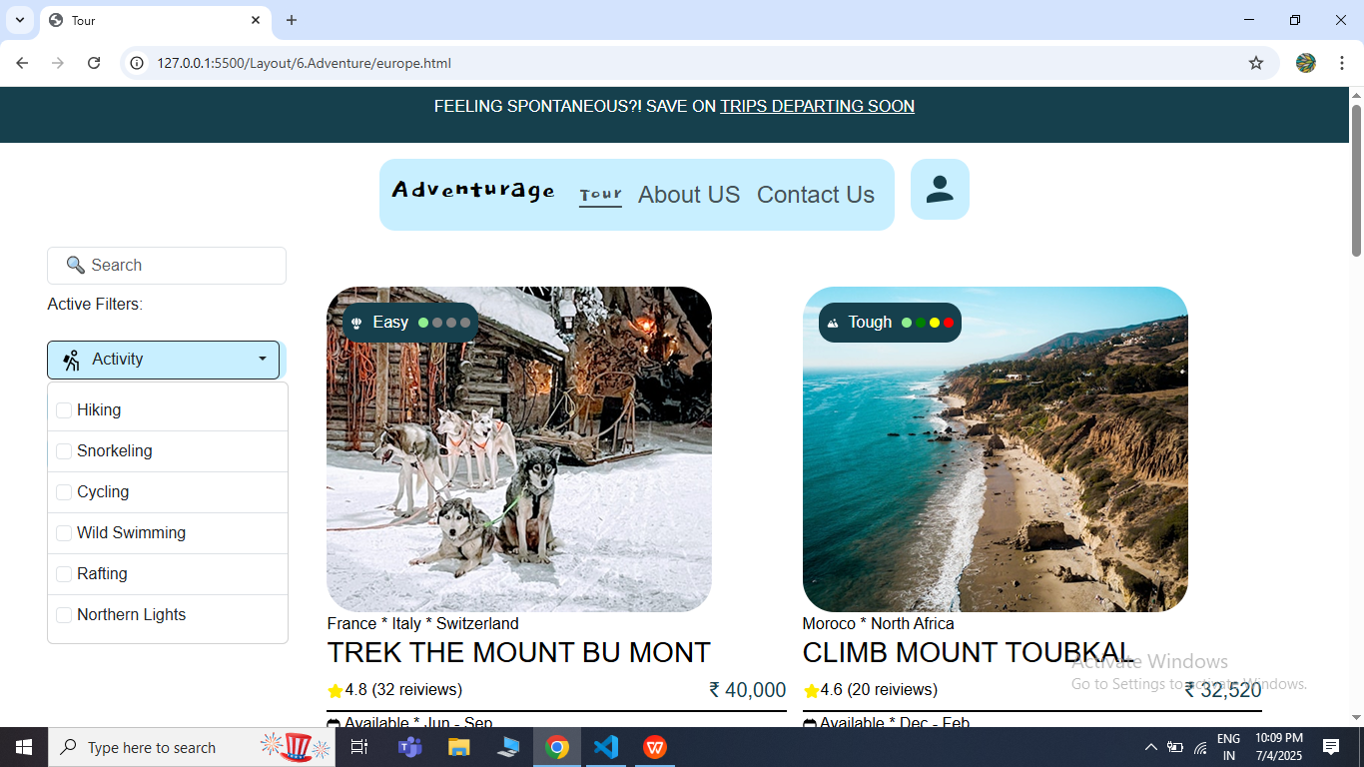

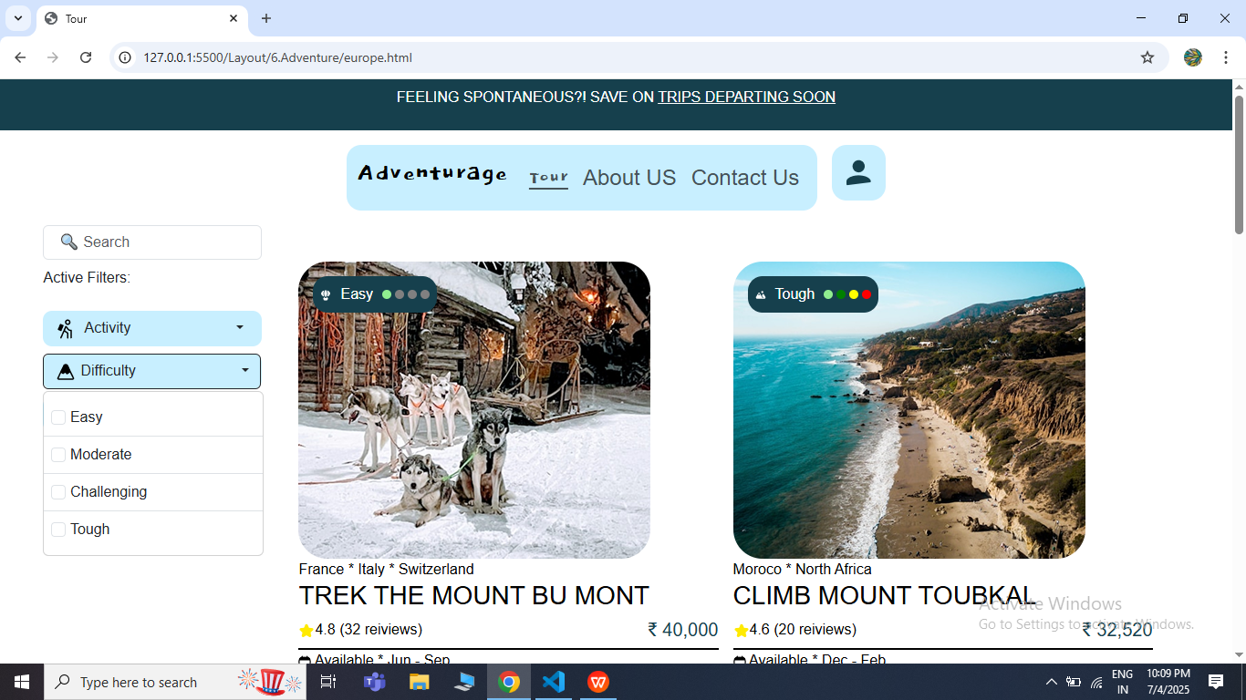

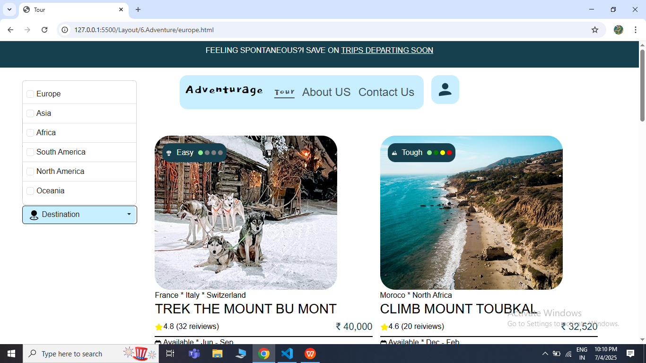

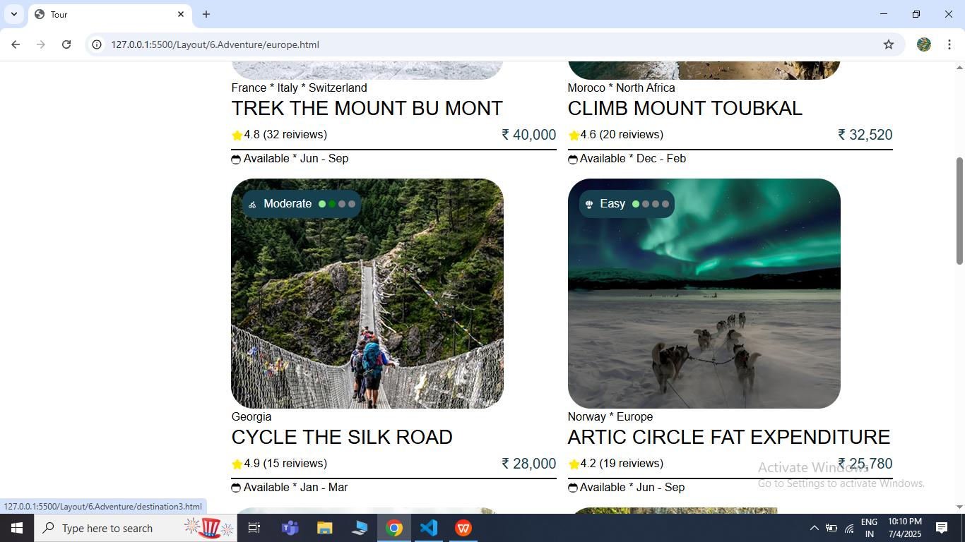

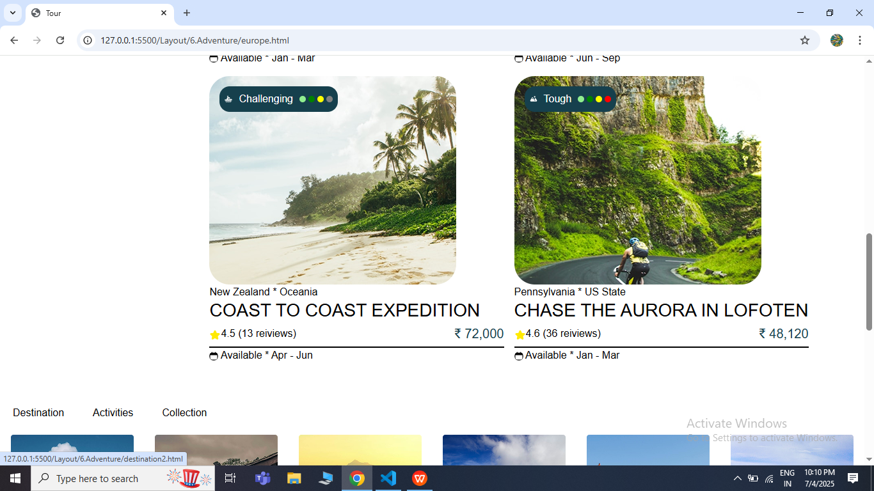

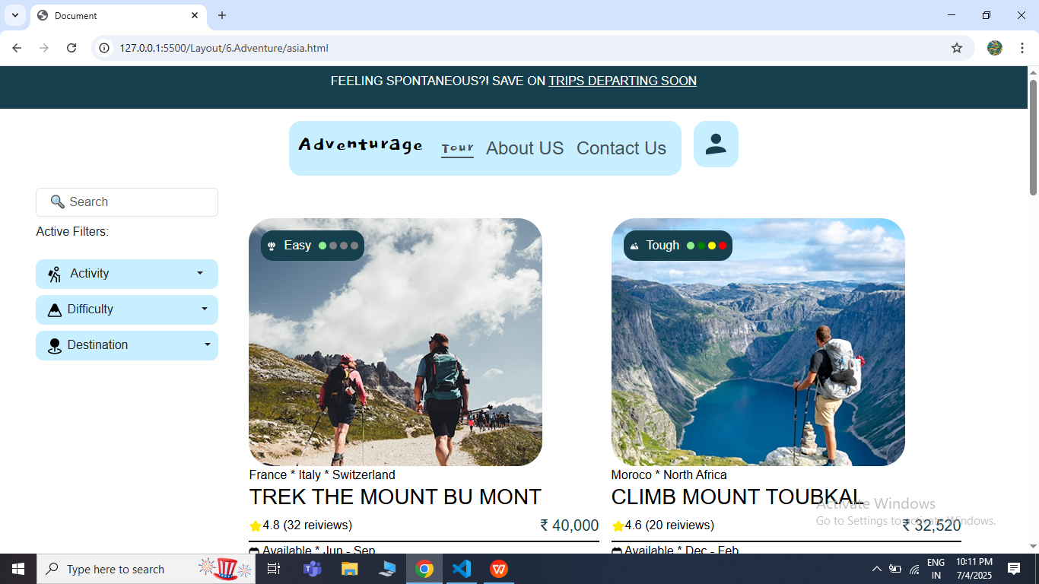

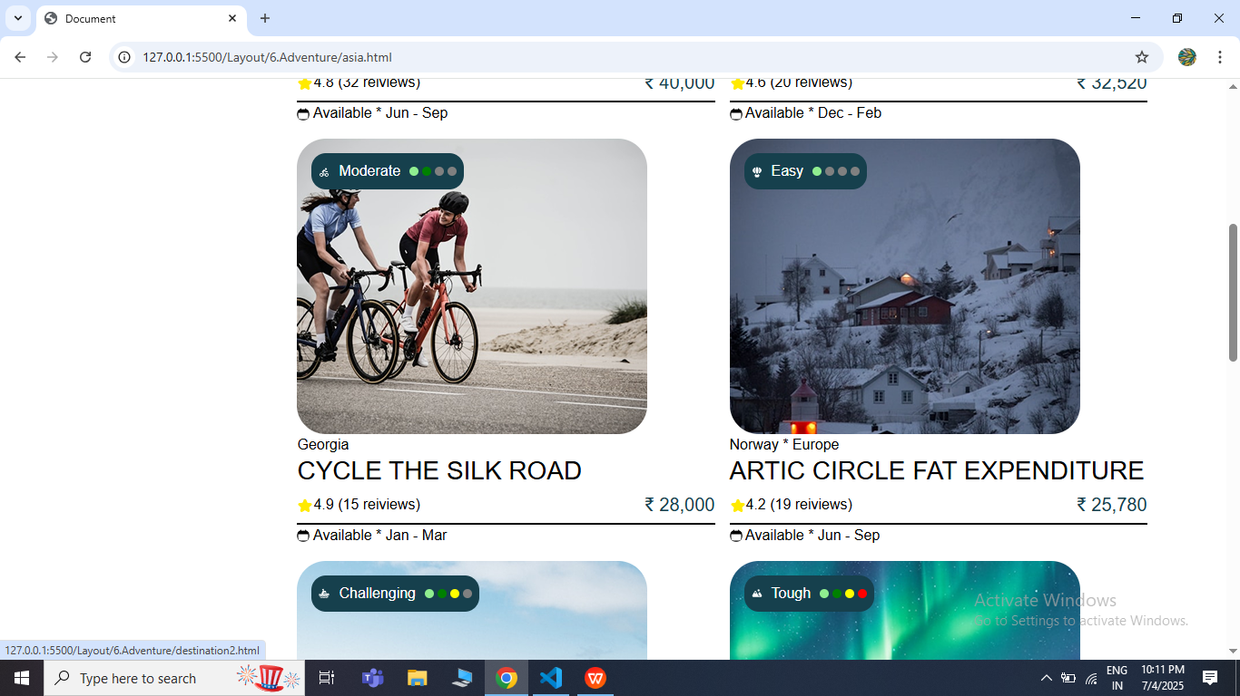

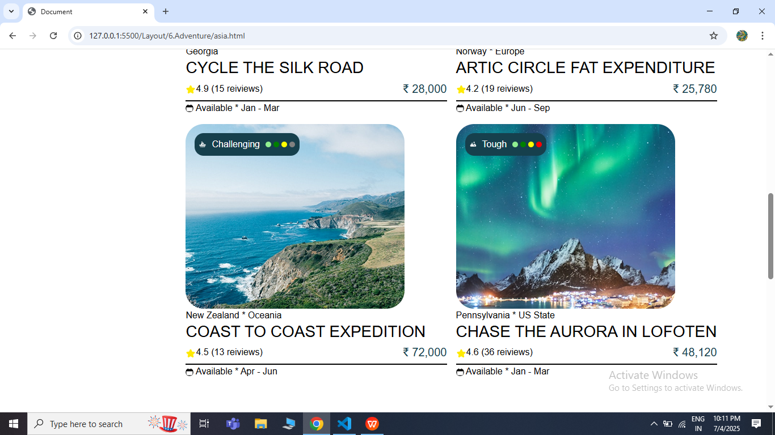

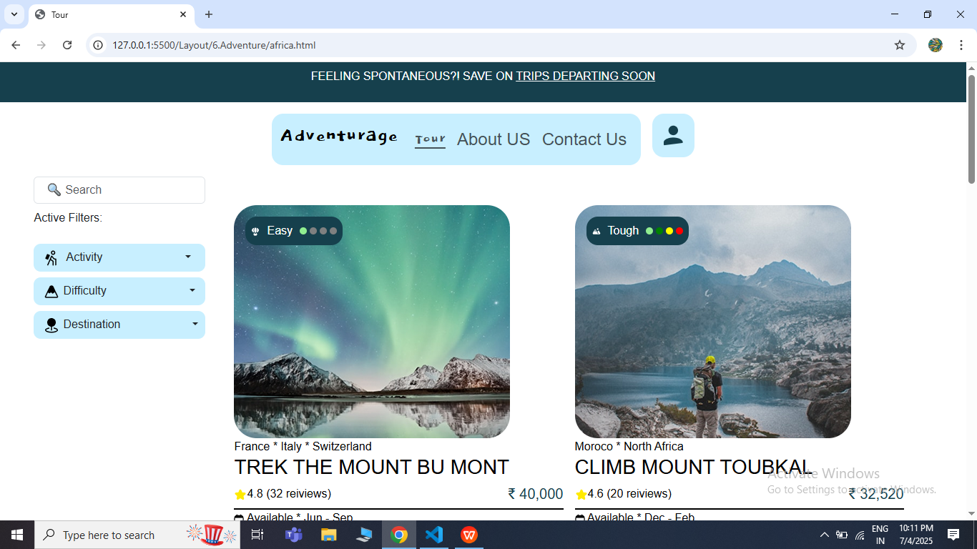

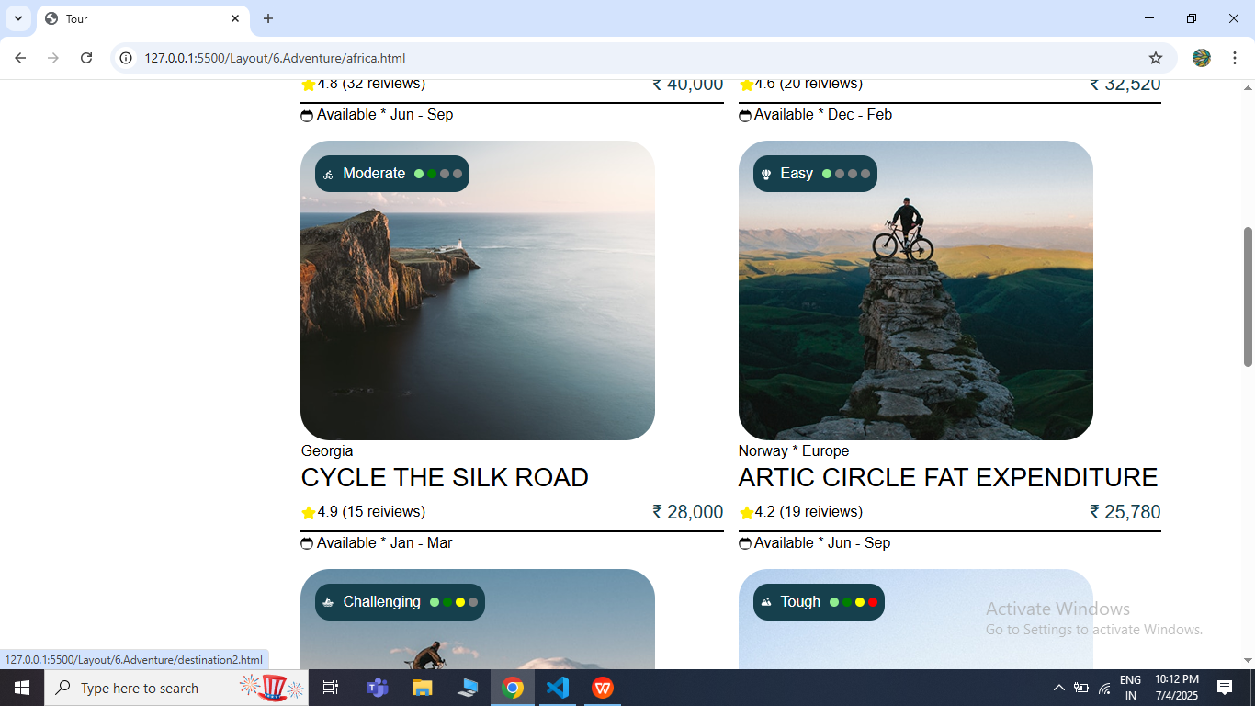

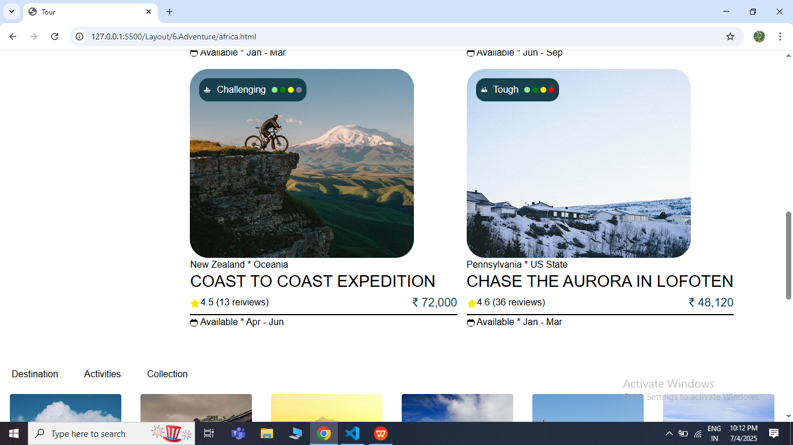

* **Destination Page**

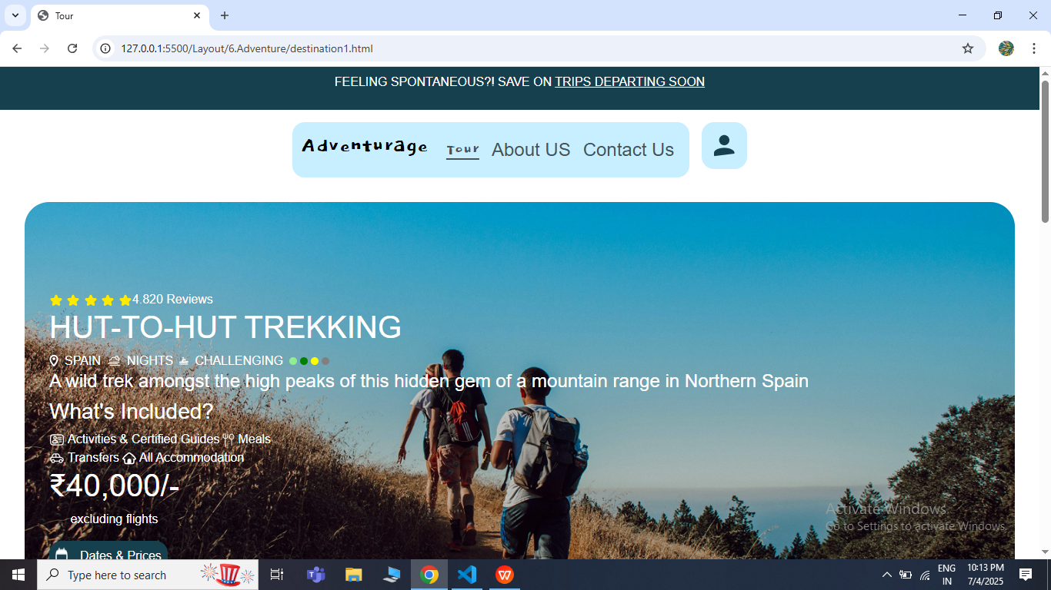

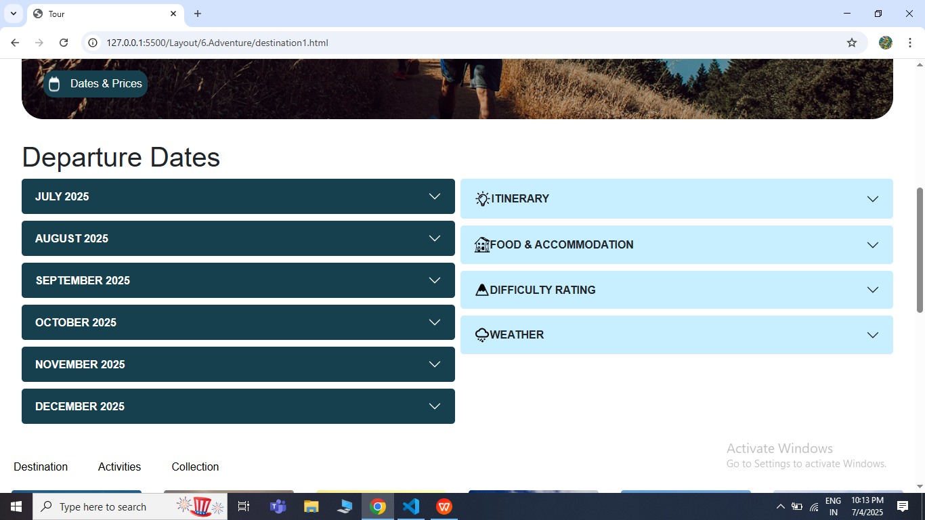

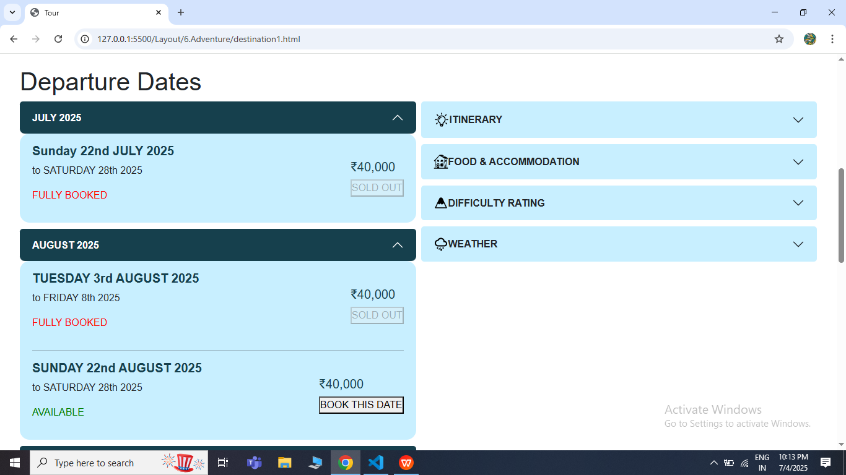

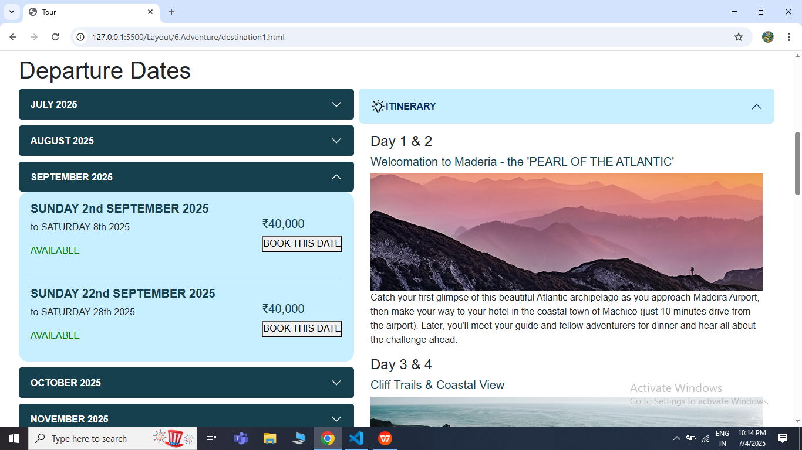

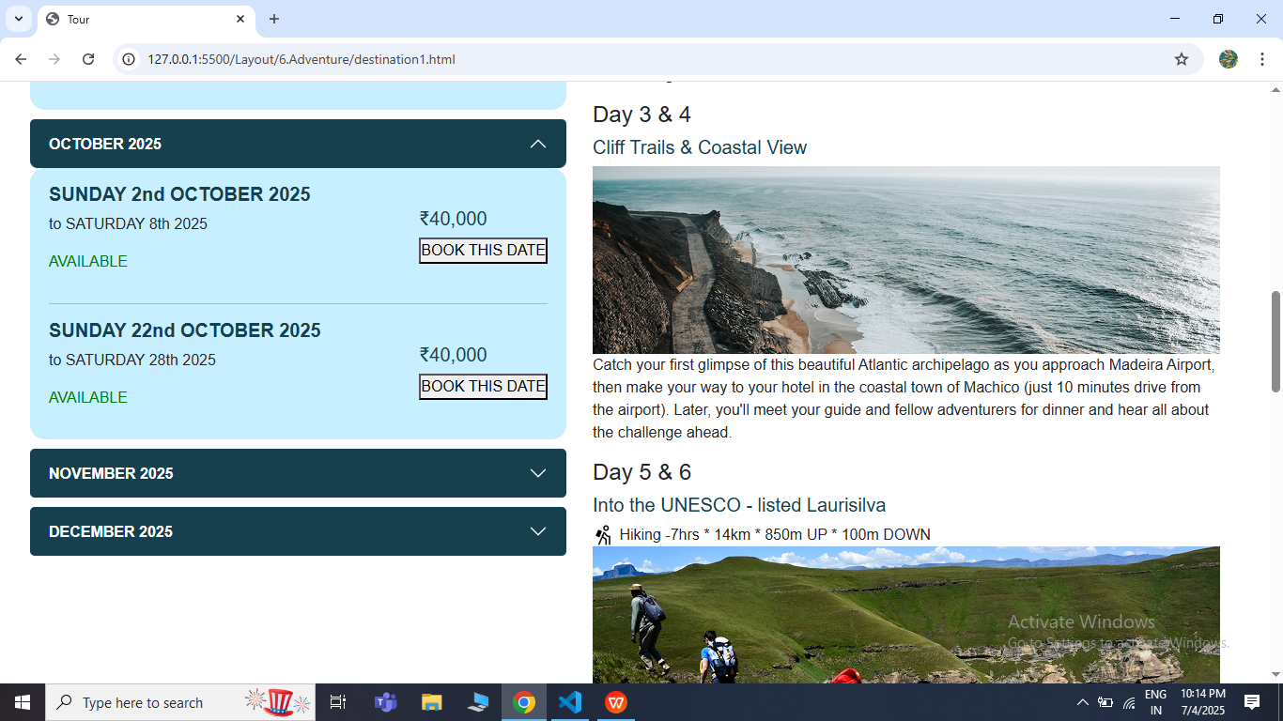

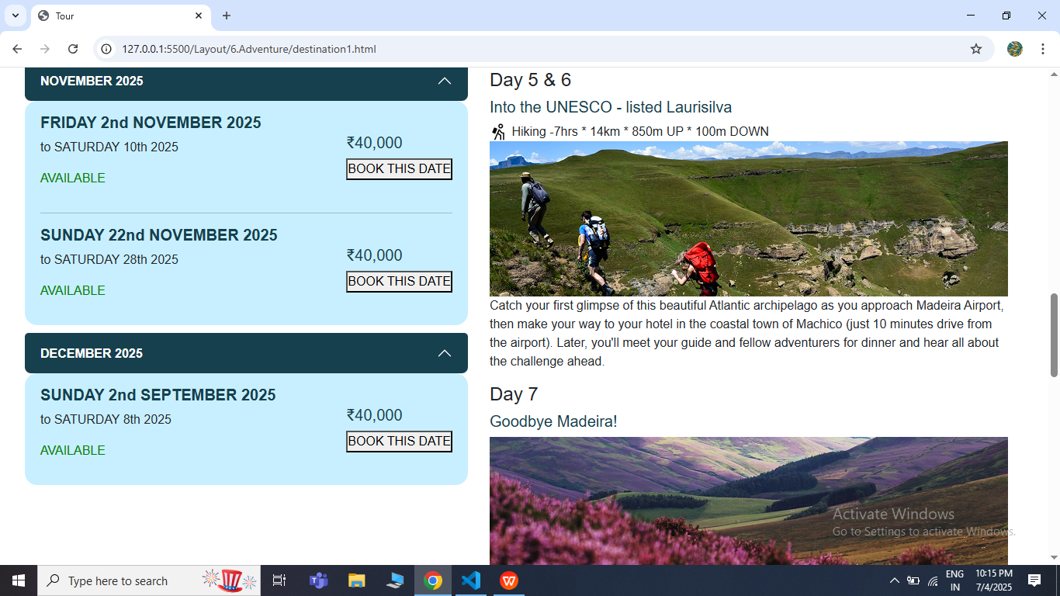

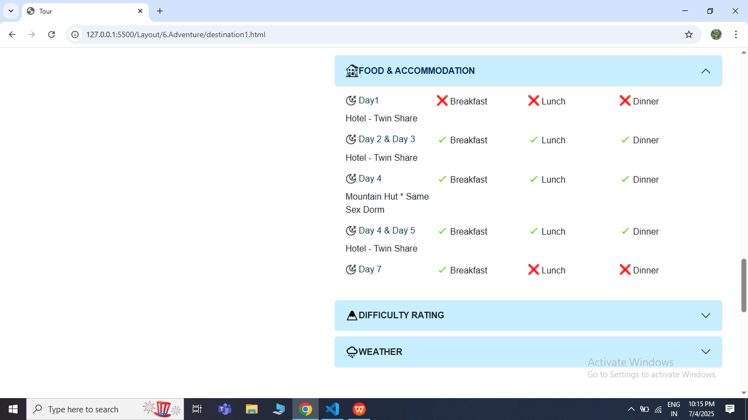

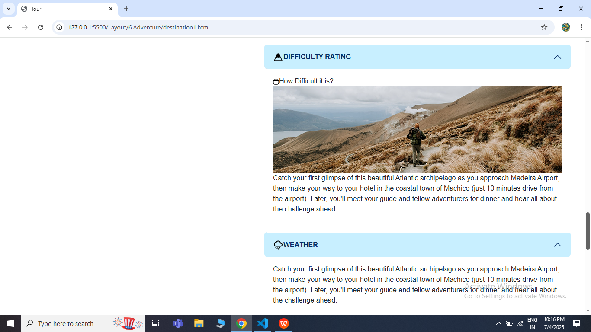

* **Booking Page**

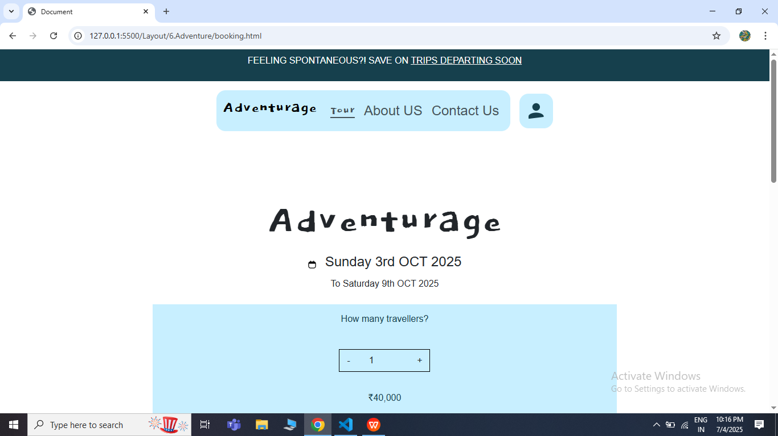

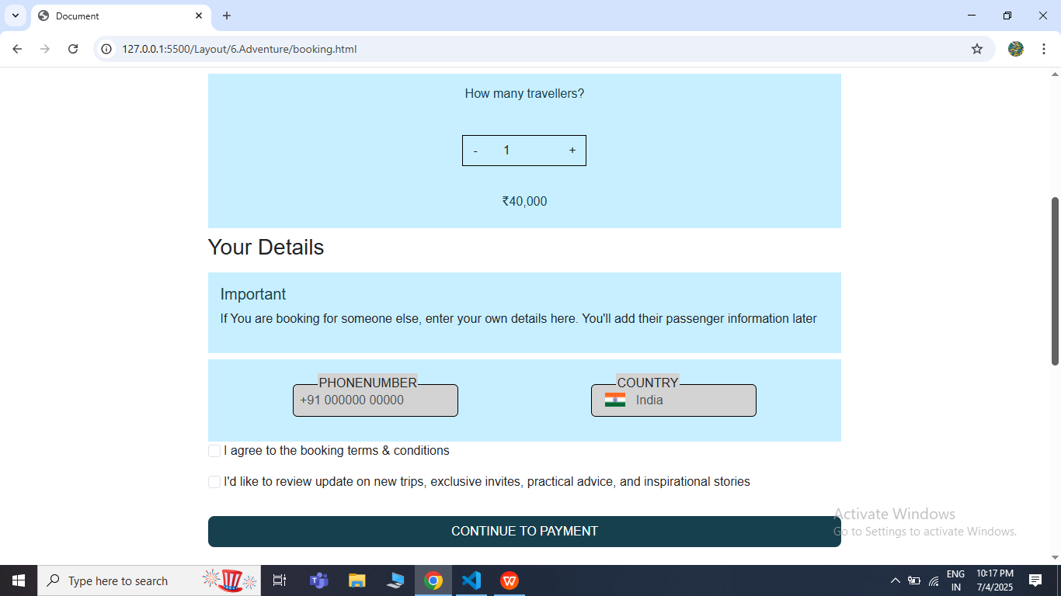

* **Payment Page**

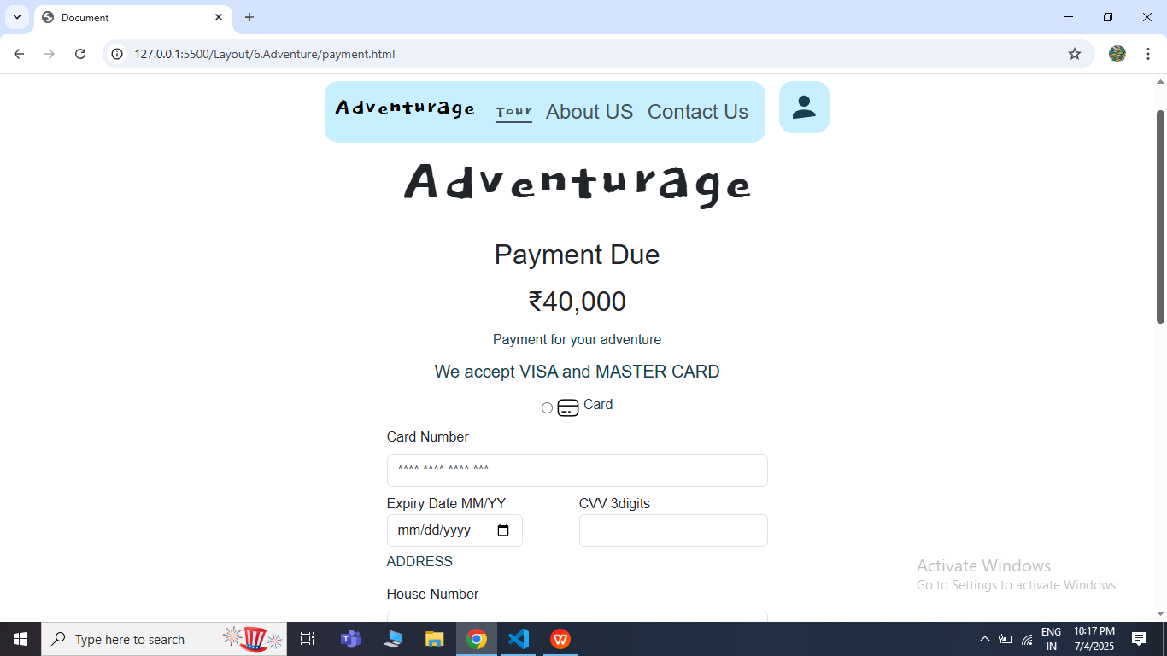

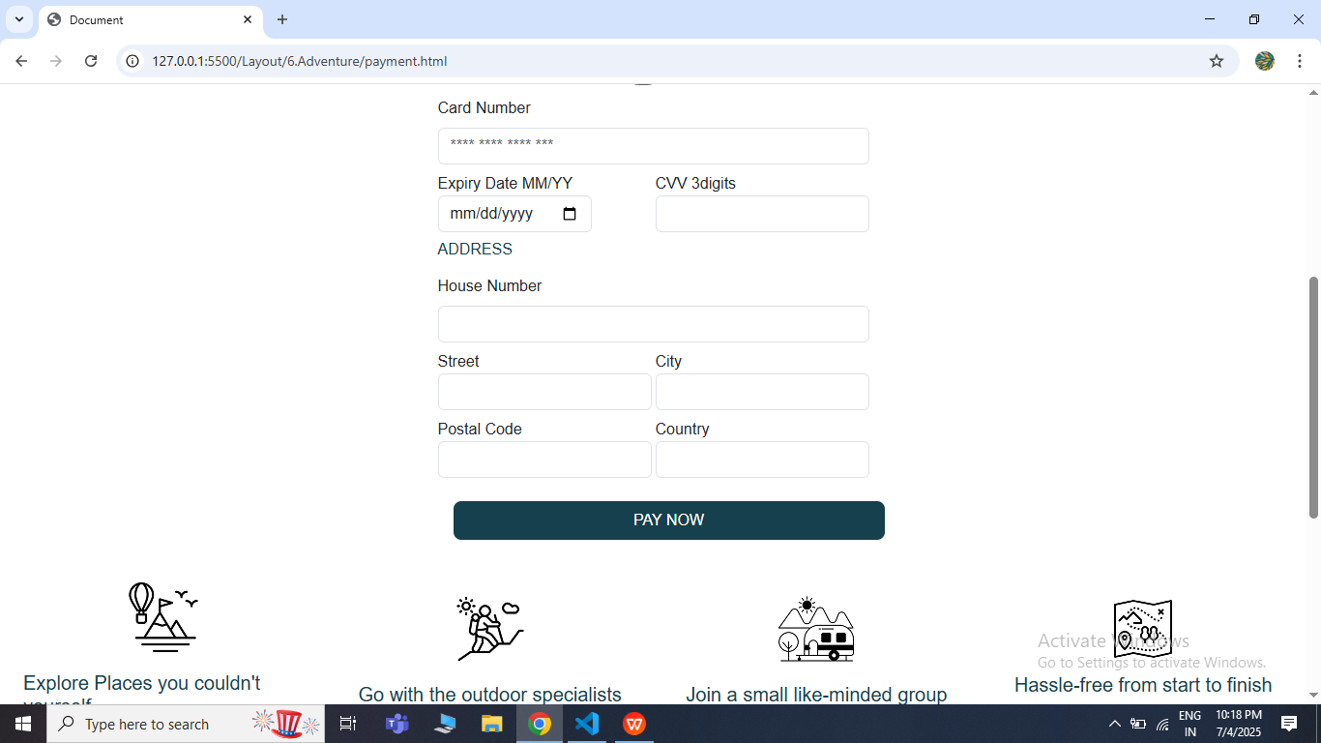

* **Booking Conformation Page**

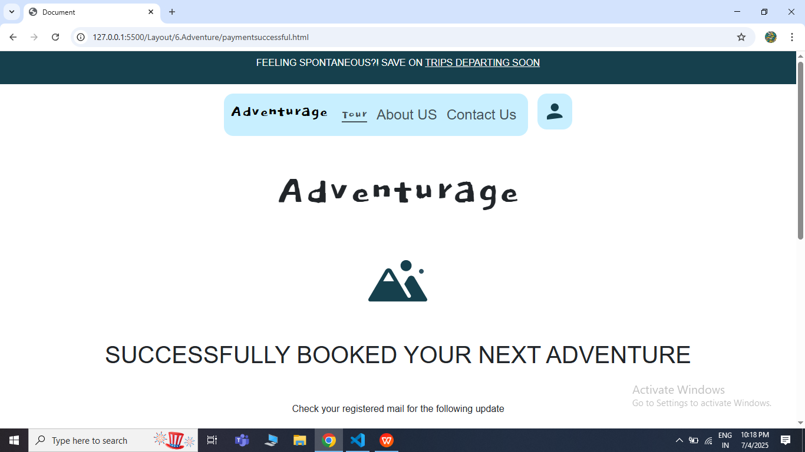

* **Our Story Page**

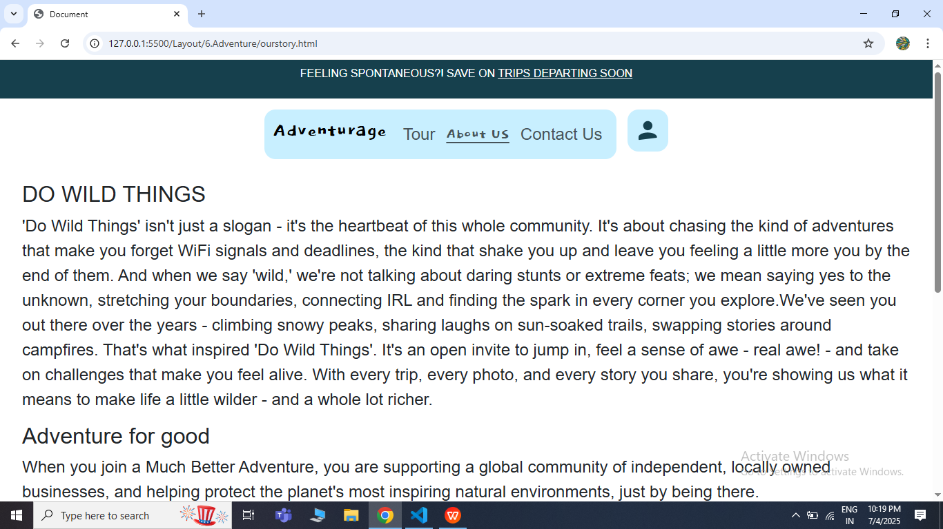

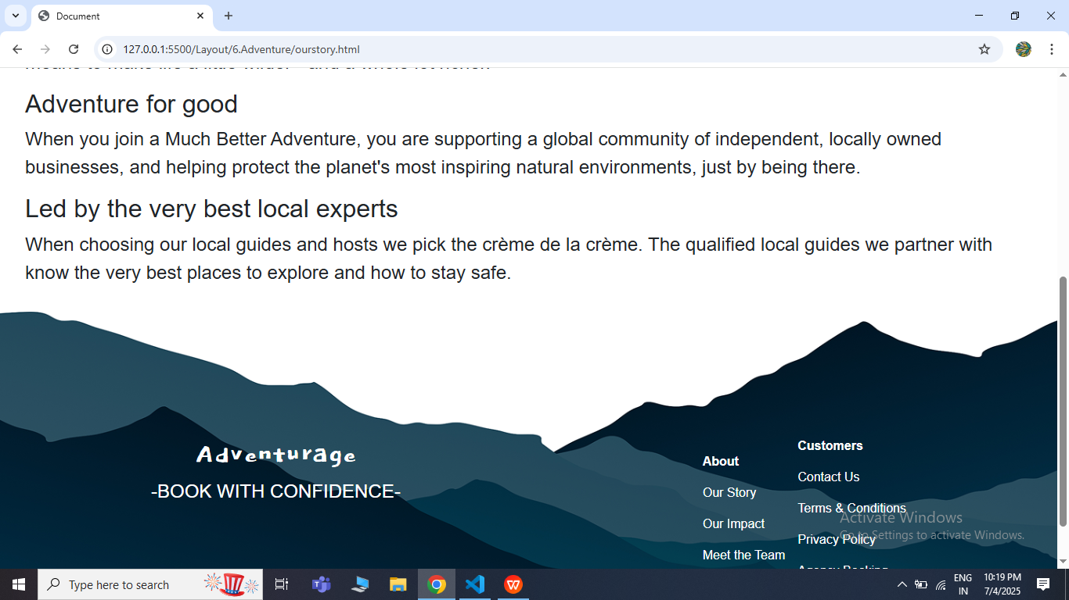

* **Our Impact Page**

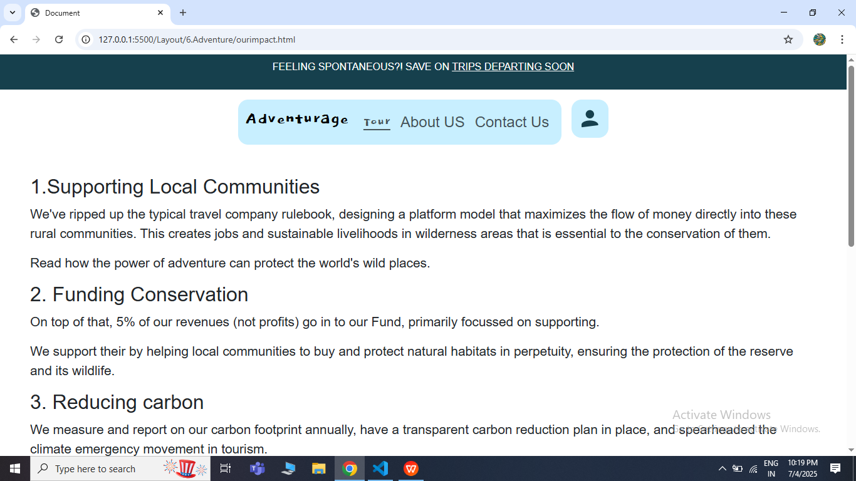

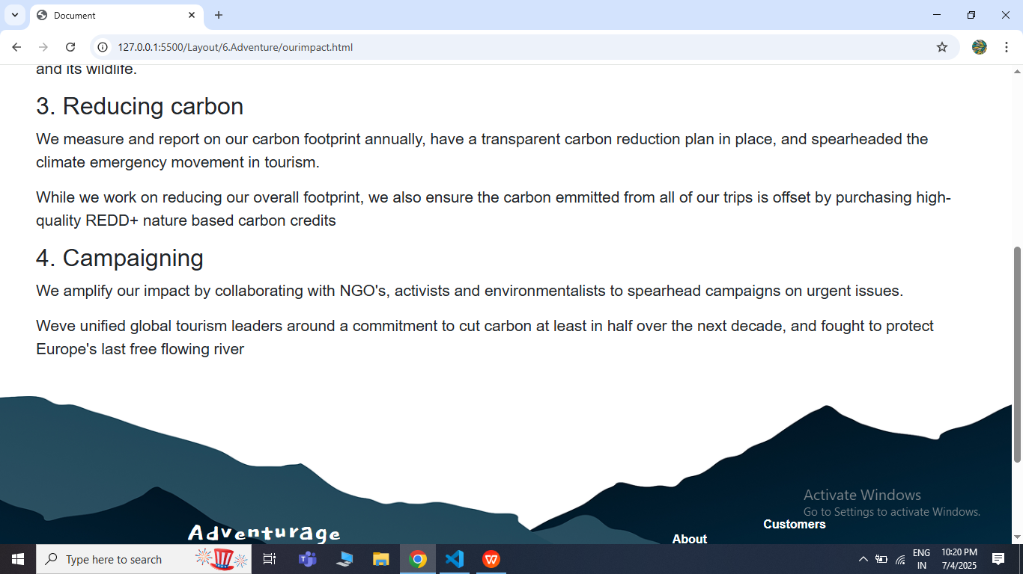

* **Meet the Team Page**

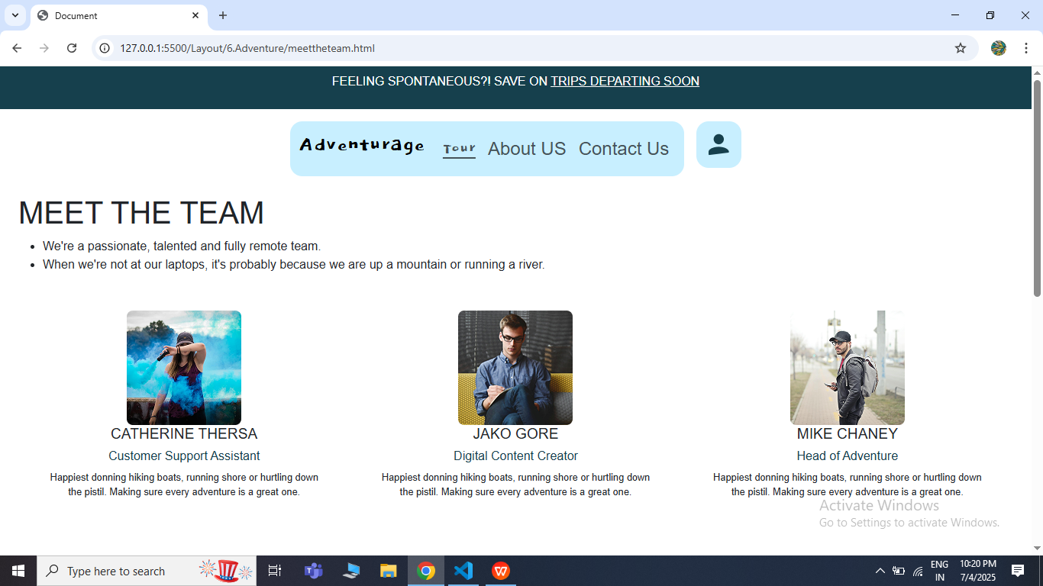

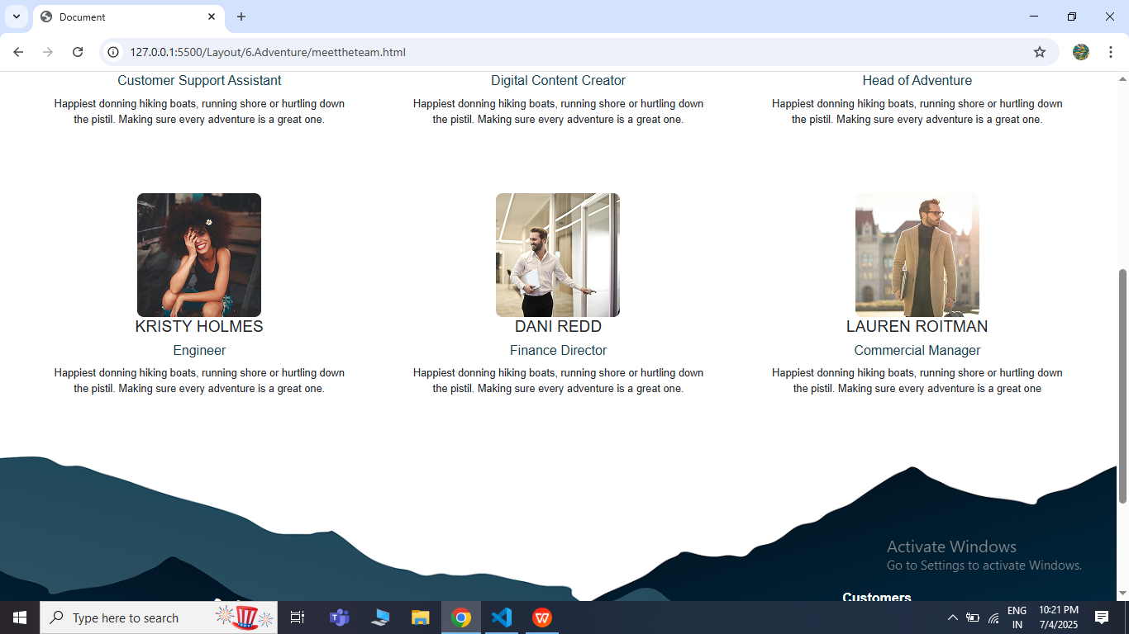

* **Privacy Policy Page**

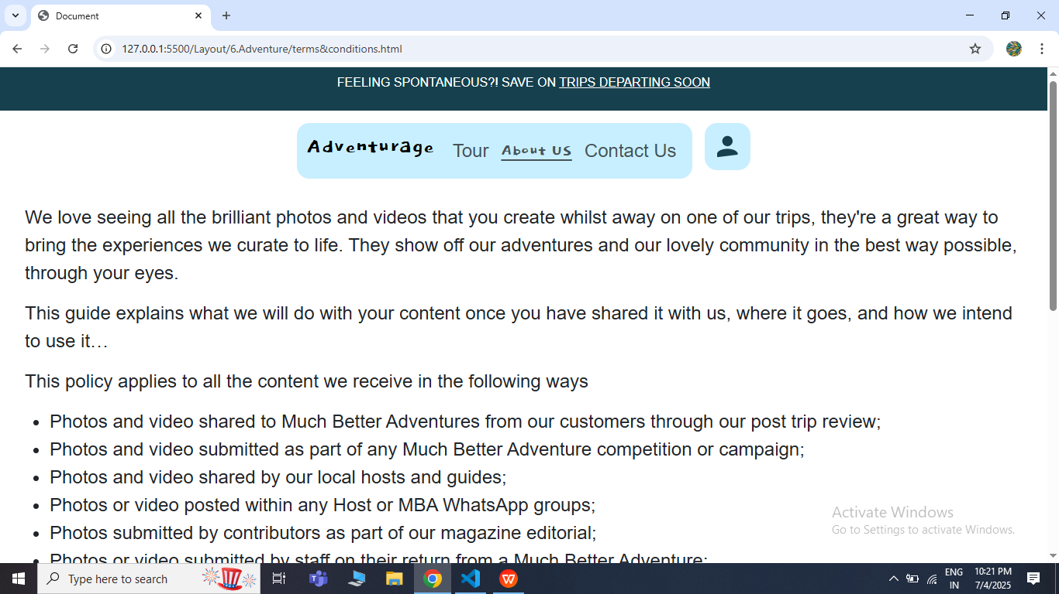

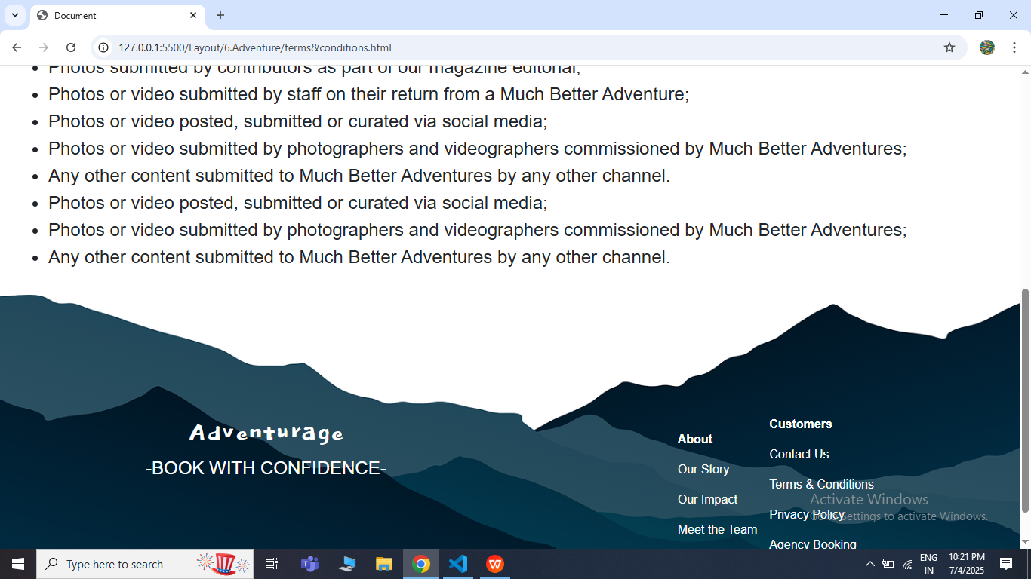

**8. Conclusion**

The Adventureage Travel Agency Booking Website aims to provide a seamless, end-to-end travel booking experience that caters to the modern adventure seeker. By integrating essential services like **accommodation**, **guides**, and **meals**, the platform will offer travelers a one-stop solution for planning and booking curated adventure tours. The platform will position the agency as a reliable and tech-forward brand in the adventure tourism market, offering convenience, transparency, and personalized travel experiences.

**Prepared By:** Nivashini D  
**Date:** 04-07-2025  
**Reviewed By:** Alagu Mari  
**Approved By:** Alagu Mari